# Application overview

## Central application

The central application contains the following parts:

* **Interfaces** for the people who run the restaurant/event and their customers
* **Database** for storing the information of each restaurant/event instance and the users
* **Services** implement the functionality of the system
* **Gateway** connects the services to the corresponding interfaces

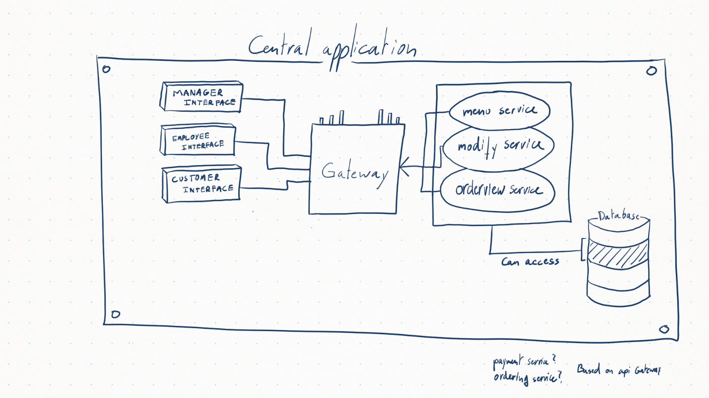

## Interfaces

The interfaces are the access point to the server for all users of the web application. Every type of user will have their own interface to communicate with the central application.

### Manager interface

A web interface is used for managing the application. Before accessing the system, the manager will have to identify themselves by entering a username and password. After logging in, they will be able to:

* Create new restaurants
* Modify existing restaurants
  + Change the description
  + Change the menu
  + Publish the web page
  + View a web page preview
* Add accounts for waiters and chefs.

### Employee interface

The employee interface is meant for the waiters and chefs. Like the manager they will have to log into the web application and have the following features available to them:

* View the order overview
* Accept orders from customers
* Accept payment from customers
* Modify the order overview to indicate dishes which are ready to serve or already completed

### Customer interface

The customer interface is what the customers will see on their device when using this application.

## Gateway

## Services

### Menu service

### Modification service

### Orderview service

### Ordering service

### Payment service

## Database

The database will be used to store all the necessary information about the different restaurants/event, but also the users that can modify and access the application.